Tool Guide – ARP Scan

Introduction
ARP Scan is a network discovery tool that uses the ARP requests to discover and fingerprint active hosts on a local network. It is used to quickly detect devices and to gather MAC addresses, and can be used for reconnaissance or host discovery phase of penetration testing, specifically to get a list of live targets.
Safety Disclaimer: Use only on networks and systems for which you have explicit authorisation. Unauthorized use of tools can be Illegal, unethical and harmful.

Setup and Launch
  - Step1: Open Deakin Detonator Toolkit
- Open Terminal in Linux
- Navigate to your Deakin Detonator Toolkit directory: (cd ~/Deakin-Detonator-Toolkit)
- Run DDT by using the following command line: (yarn run tauri dev)
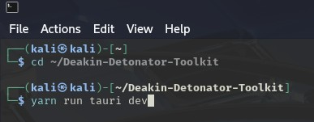
  - Step2: Find Tool-example
- Click on Tools to the left (or use the quick search bar)
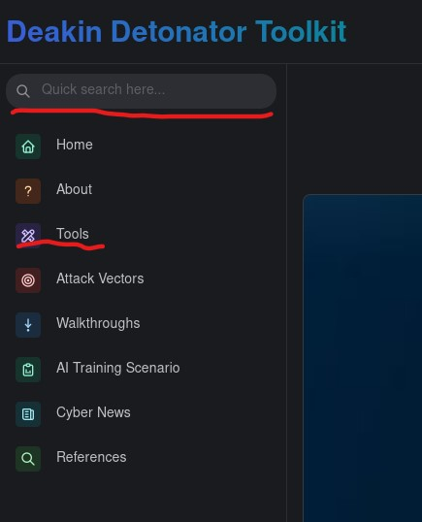
- If you clicked on Tools, scroll down and find ARP scan and click go

Configuration and Usage
  - Step3: Configuring ARP scan
- You will be presented a single field, “Network Interface”, you can insert the network interface you want to check If you already know it.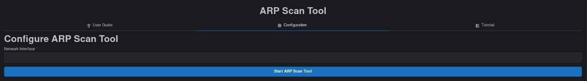
  - (optional) if you are unsure of your network interface, open a terminal and use the following command: (ip link show)
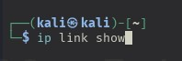
  - (optional) you will most likely see multiple different options, for example lo (loopback, you can ignore this one), eth0 (older naming for wired ethernet connection), enp0s3/enp3s0 (more modern naming for wired ethernet connections), wlan0/wlp2s0/wlp3s0 (wireless interfaces), pick the one you want to check.
- Click the “Start ARP Scan Tool” button and you will be prompted to give your password, do so to continue

  - Step4: Results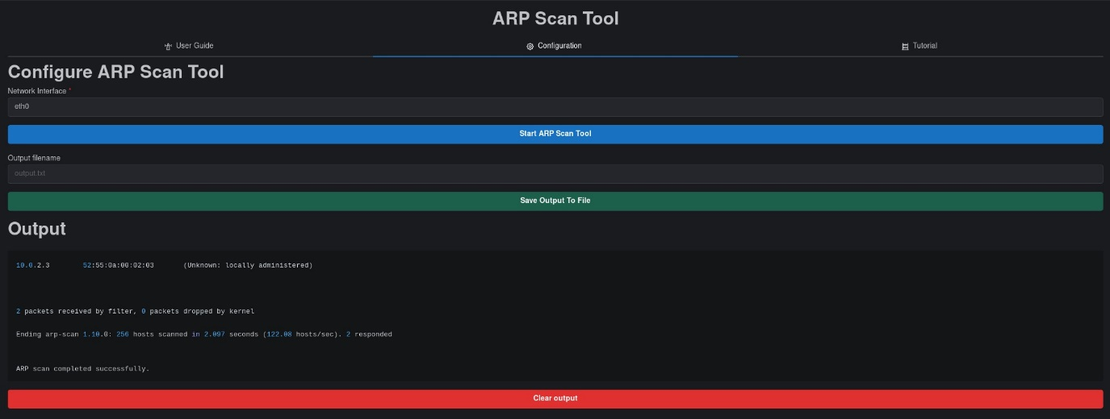
- You will be given an output that should end with “ARP scan completed successfully” and be sure to scroll up in the Output field to see the rest.
- Optional: You can save your output by filling out the new “Output filename” field with an appropriate name (output.txt) and then clicking “Save Output To File” button
- Optional: You can copy your output to your clipboard by clicking the little clipboard in the top-right of the output area.

Output Explanation
Note: your output will naturally be dependent on what network interface you checked and your devices, the following is non-comprehensive example output of an eth0 interface, with addresses changed.
- $ pkexec arp-scan --localnet -I eth0
  - This is the command used by the ARP scan tool to check the eth0 interface
- Interface: eth0, type: EN10MB, MAC: 00:11:22:aa:bb:cc, IPv4: 10.0.2.50
  - Interface: eth0 is your current interface
  - MAC is the device hardware address
  - IPv4 is the system’s local IP on the network
- Starting arp-scan 1.9.7 with 256 hosts (https://github.com/royhills/arp-scan)
  - The start up banner of ARP scan tool
- 10.0.2.1 52:54:00:12:34:56 (unknown: locally administered)
  - 10.0.2.1 IP address
  - 52:54:00:12:34:56 MAC address
  - (unknown: locally administered) Vendor info
- 2 packets received by filter, 0 packets dropped by kernel
  - How many packets matched the capture filter (ARP replies)
  - How many Packets the OS kernel couldn’t delivered to tool because buffers were full, zero is ideal.
- You should just see and ending message after that.

